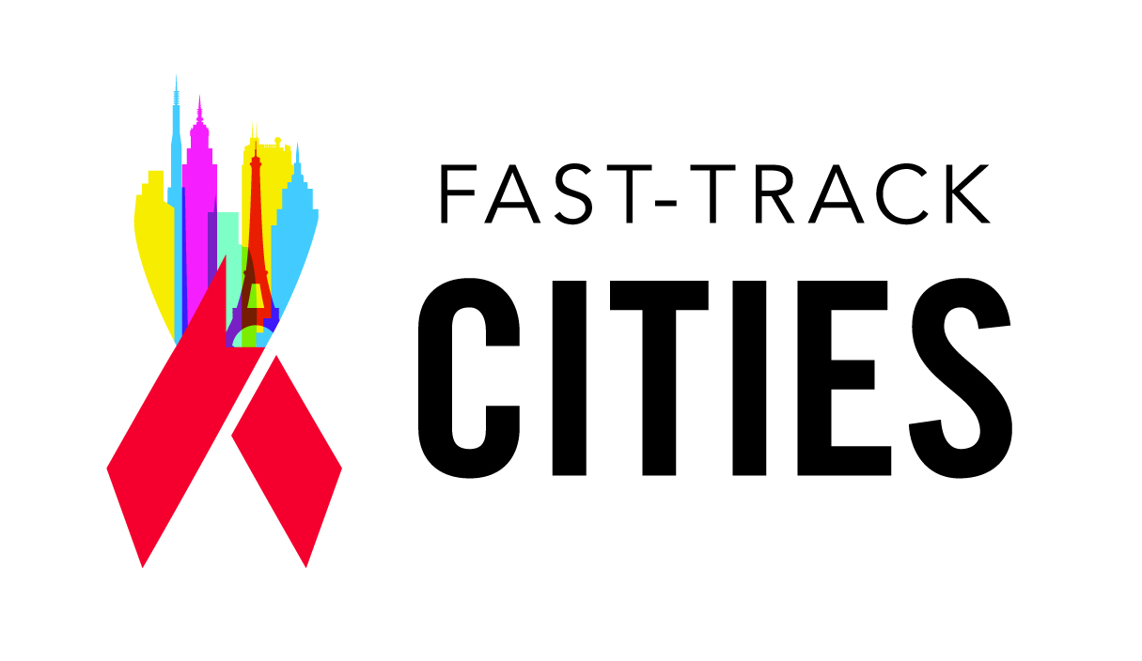
City FTCI Meetings – Moving from Commitment to Action
The Fast-Track Cities Initiative (FTCI) aims to build upon and leverage existing HIV programs and resources to strengthen citywide responses to end the AIDS epidemic by 2030 by reaching 90-90-90 and zero stigma and discrimination targets by 2020. Cities are uniquely positioned to develop locally relevant, locally tailored, locally led strategies that respond directly to the needs of vulnerable and key populations within the urban context.
City FTCI meetings can convene stakeholders to draft and implement a city-specific Action Plan and are crucial to enabling a coordinated citywide response.
Types of FTCI meetings to consider as part of Process and Oversight include: 1) Task Force Planning Meetings; 2) City Consultations; 3) Working Groups/Consultation follow-up meetings.
Task Force Planning Meeting
Details | Objectives
Purpose: This meeting will bring together the FTCI Task Force, a group of core stakeholders responsible for leading the city’s AIDS response, to initiate FTCI work and plan for a city-wide consultation.  Participants: The Task Force consists of 5-10 stakeholders including: the Mayor (or representative), IAPAC KOL, City health director or City HIV director, NGO leadership, and a PLHIV. Cities may choose to include other relevant key stakeholders such as a district/state/county health officials or donors.  Format: Keynotes, presentations, and facilitated discussion | - Introduce members of the Task Force and define roles  - Define the city’s current response and epidemiology  - Understand the different components of the Fast Track Cities Initiative  - Plan the city-wide consultation including logistics such as agenda, venue, date, and LoP

City Consultation Meeting
Details | Objectives
Purpose: Consultations will bring together stakeholders throughout the city to forge a coordinated AIDS response. Consultations are co-hosted by the Mayor’s office in partnership with the International Association of Providers of AIDS Care (IAPAC) and FTCI’s core partners, and co-chaired by the Mayor (or her/his designee), a clinician-leader, and a person living with HIV (PLHIV).  Participants: Participants will include civil society representatives, elected officials and health officials, healthcare providers, and other relevant private and public sector stakeholders.  Format: political keynote speakers, plenary sessions with expert speakers, and interactive, thematic breakout sessions. | - Develop consensus among stakeholders around 90-90-90 targets  - Establish baselines (e.g., epidemiology, clinical and public policies, financing, etc.)  - Strategize for a coordinated response and draft the city’s Action Plan around the FTCI’s 5 implementation points:  1) Process and Oversight: Identify a Process and Oversight plan to facilitate a coordinated response.  2) Monitoring and Evaluation: Develop consensus on indicators to measure local FTCI progress and set targets and timelines. Preview the web portal as a M&E and communications tool.  3) Program Interventions: Discuss potential evidence-based interventions to address gaps across the HIV care continuum and define capacity building needs for HIV care continuum optimization.  4) Communications: Develop a communications plan to inform and actively engage communities and stakeholders in FTCI activities  5) Resource Mobilization: Develop a plan for financing FTCI activities including securing funding and optimizing efficiency of existing funding.

Working Group/Post-Consultation Meetings
Details | Objectives
Purpose: These meetings will follow up on action items and deliverables agreed upon during the City Consultation and will inform revision of the Action Plan as needed.  Participants: Consultation participants will form working groups, which may be divided thematically, by implementation point (Process & Oversight, M&E, Programs and Interventions, Communications, Finance), or by stakeholder category (i.e. government, community, health providers, health officials, etc.).  Format: Working groups may take place regularly, such as monthly or quarterly. It will be led by a member of the Task Foce and will mainly involve facilitated discussions. | - Re-visit the Action Plan and update on accomplishments and gaps  - Address barriers for targets that were not reached  - Revise Action Plan as needed with new targets and timelines  - Draft Quarterly Report on FTCI progress

